CA02



Dovydas, Klisys
B00165094

Department of Engineering
School of Informatics & Engineering
Technological University Dublin, Blanchardstown
Dublin 15.

Object-Oriented Programming
18 March 2025

Contents
Introduction: 3
Tests for point class: 3
Designing: 3
Build: 4
Test Outcomes: 4
Orbit.cpp App: 5

Introduction:
Here are the requirements for this CA:
- Creating a header file with a namespace called geom.
- Design a UML diagram for the point class.
- Inside the geom namespace, define the point class private and public members.
- Copy the harness.cpp file and check if desired results are obtained
- When harness.cpp works, design a planets.cpp file which simulate planet rotation.

Tests for point class:
Function | Expected Result
P1.translate(-1.0, 1.0) ; | (2, 6)
Point p2(p1); | (2, 6)
p2.rotate( (Point){1,1}, 90*M_PI/180 ) ; | (-4, 2)
p1.distance(p2); | 7.2111

Designing:
The UML diagram of the point class:
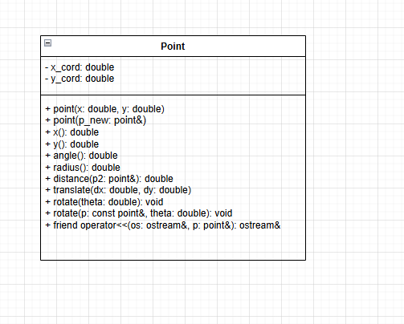

Build:
Short description on the code design:
- Point class is defined in the namespace, must use ‘using namespace geom’ to utilize point class.
- The private members are defined at the start: x_cord and y_cord.
- Contains a constructor for defining co-ordinates of a point.
- Uses a copy constructor to define a new point’s co-ordinates.
- Utilizes math functions for easier parameter findings. E.g. double distance (point& p2);
- To find the rotation of a point around another point, the point is translated to origin, rotation is applied and then the point is translated back to original co-ordinate position.

Test Outcomes:
$ make run01
---------------------
Running harness.exe
../../bin/harness.exe
(2,6)
(2,6)
(-4,2)
7.2111

The desired outputs were produced from the harness code that had been copied.
This verifies that the point class works correctly, and it can be implemented into the orbit.cpp code.

Orbit.cpp App:

